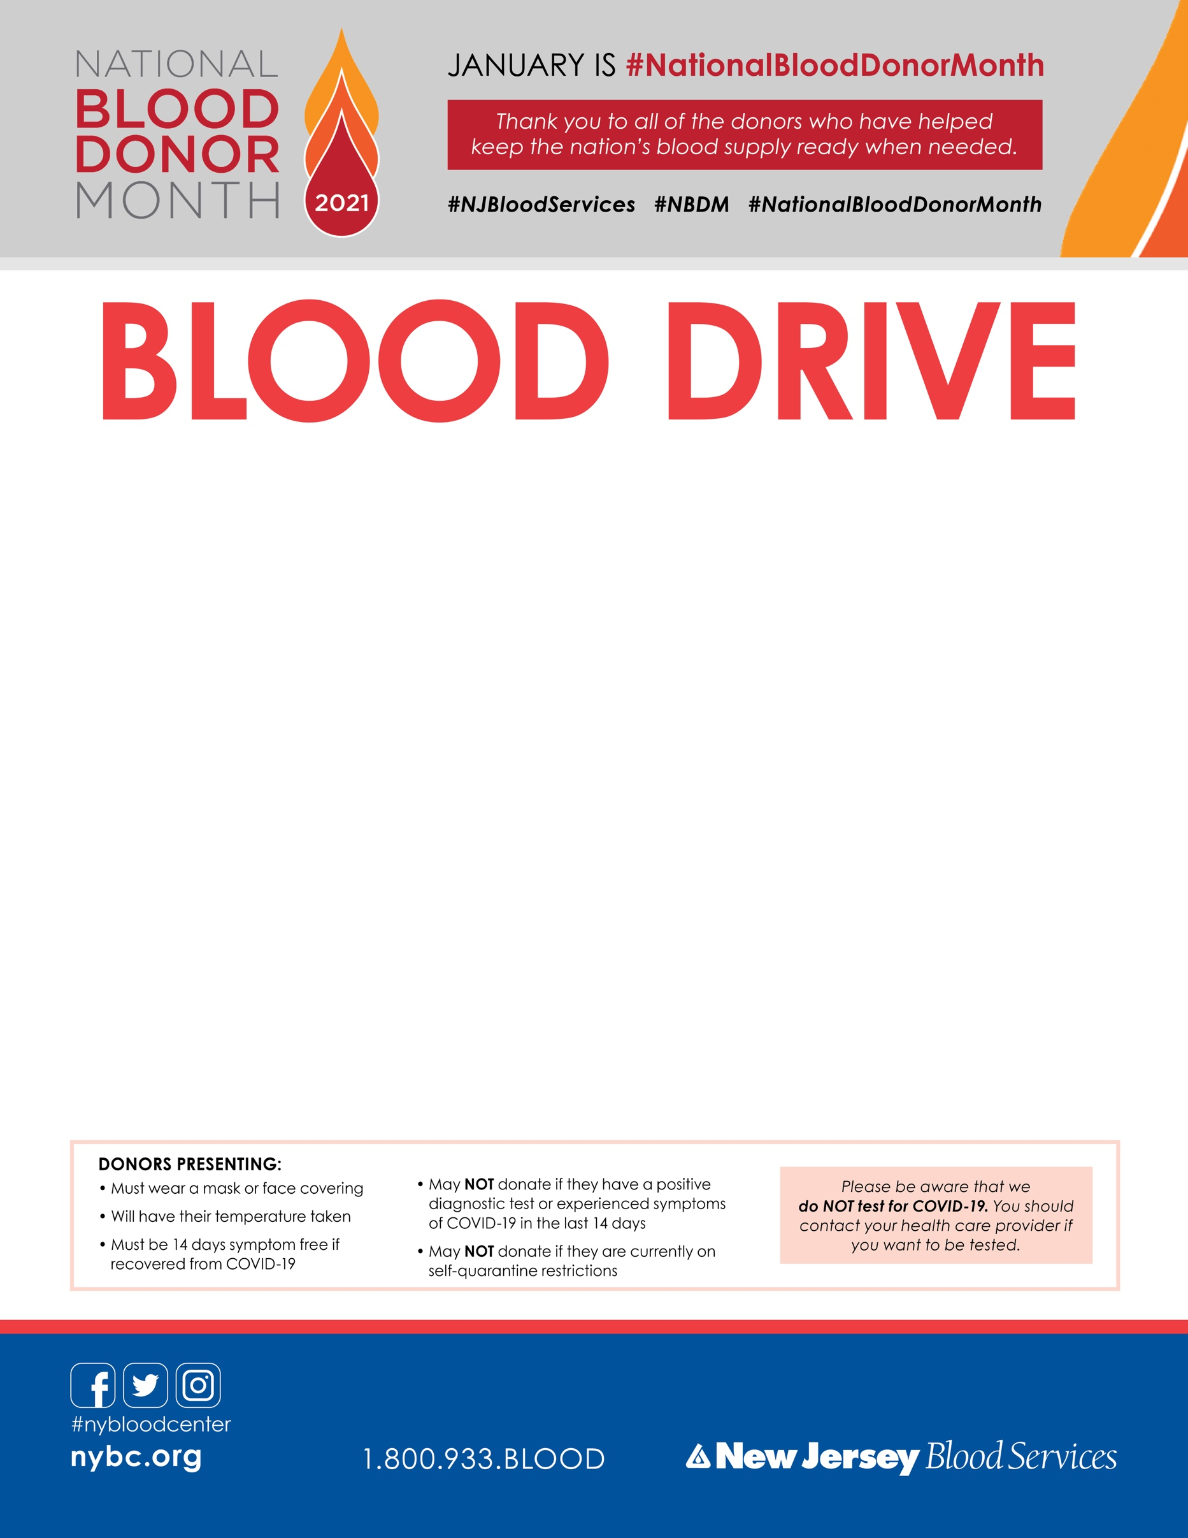­­

**Sunday January 17**

**Morristown Jewish Center**

**8:30am-1:00pm**

**177 Speedwell Ave Morristown**

**Appointments preferred**

**to sign up:** [**smarturl.it/NJBS_Drive**](https://smarturl.it/NJBS_Drive) **sponsor code 13702**

**or call 1-800-933-BLOOD(2566) or text Barb Pearson 732-616-8146**

Please remember to eat, drink and bring your donor ID card or ID with name and photo.

**Please remember to eat, drink and bring your donor ID card   
or ID with name and photo.**