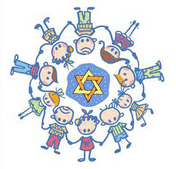
Shalom Yeladim-The Judie Gerstein Early Learning Center of Morristown Jewish Center
Invites the Community to
“Growing Together Shabbat”
Friday mornings for the school year
when Shalom Yeladim is in session
Oct. 7,14,21,28/ Nov. 4,18/ Dec. 2,9,16,23
9:30am
Child-Friendly Service, stories, sing, pray
Snack & celebrate Shabbat Together. Birth to Kindergarten.
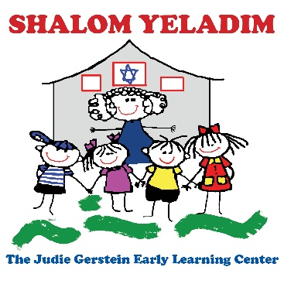
Led by Rabbi Nesson and Cantor Shana
For more information call 973-538-8284
Or visit www.mjcby.org
177 Speedwell Avenue Morristown, NJ

