Morristown Jewish Center Beit Yisrael
Adult Education Movie of the Month

Sunday, January 31st at 7:00 PM in the Frigand Hall

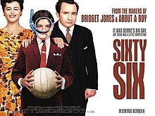

Bernie Reubens (Gregg Sulkin), a young Jewish boy, is about to have his bar mitzvah. Initially, he meticulously plans a lavish reception to upstage that of his older brother Alvie (Ben Newton), but as the family's finances lurch from one disaster to another, the family is forced to lower Bernie's expectations and stage the bar mitzvah reception at home in North London. When England reaches the 1966 football World Cup Final, most of the guests make excuses not to come to the reception so that they can watch the game.

