The Search for Hametz Passover April 14th

Here's how it works:

- Take some pieces of bread, and hide them around the house. In our house we put one piece in each room and not too hidden- after all we do not want to find them during Passover! ( some Rabbis suggest you hide at least 10 pieces)
.
- After sunset, turn off the lights.
Then, light the candle, hold it together with the feather, the spoon and paper bag, and recite the following blessing: Baruch atta Ado-noy Elo-hai-nu Melech ha'olam asher kid-sha-nu b'mitz-vo-sav v'tzi-vanu al bee-ur chametz. [Blessed are you, Lord our G-d, King of the universe, who has sanctified us with His commandments, and commanded us to remove the chametz.]

- Next, go around to each room in the house with your candle, feather, spoon to search for chametz in all the rooms of your house. When you find the chametz by the light of the candle, you use feather to sweep the hametz on to the wooden spoon, and use the spoon to put the hametz it into the bag.

- When you finish the search, place the extinguished candle and feather and the wooden spoon together with the chametz in the bag. Close the bag securely and put it in a safe place.

- After the search say the following: All leaven and anything leavened that is in my possession, which I have neither seen nor removed, and about which I am unaware, shall be considered nullified and ownerless as the dust of the earth.

- The next morning, around 10 am, you take your bag with the hametz and burn the hametz. We usually do this outside, but we know some families who do this in the fireplace.

In the morning you repeat the blessings on the reverse side.

(See Back of Page)

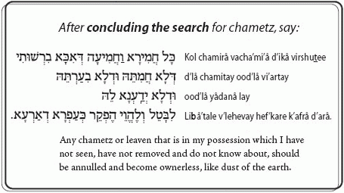

So, as you enjoy your Purim Hamentashen, remember, very soon, it is time to start cleaning
for Passover

Hag Samaeach. May you have a happy Purim and an easy time cleaning for Passover

Rabbi Nesson

