Schedule 7 Instructions for Various Honors
Friday Evening Instructions
Instructions for Opening the Sanctuary Doors for Lecha Dodee:
1. When the Rabbi announces that we turn to page 21, go to the back of the Sanctuary and stand by the double doors that are the entrance to the Sanctuary.
2. Wait by the doors until we reach the last paragraph on page 22. The Rabbi will then ask the congregation to rise and face the back of the Sanctuary.
3. Once the Rabbi makes the announcement for the congregation to rise, open the doors of the Sanctuary.
4. Keep the doors of the Sanctuary open until we finish that paragraph. When everyone turns around and faces the front of the room, you may close the doors and return to your seats. (NOTE: The door on the left closes very slowly. You do not have to pull on it. It will fully close by itself.

Instructions for Opening the Ark for Aleinu on page 51.
1. Aleinu is done immediately after the Rabbi completes his sermon. When the Rabbi completes his sermon, he will announce the Aleinu prayer on page 51.
2. Please walk up to the bimah, go to the right side of the ark and open the ark. The drawstrings for the ark curtain are on the right side.
3. When Aleinu is concluded, please close the ark curtain and return to your seat.
Instructions for Honors on Shabbat Morning
Instruction sheets are provided for ark openings, carrying the torah, the aliyahs, tying the torah and the parental blessing (optional). Please ask the people with the honors to sit in the first 7-8 rows to make it easier to find them when they are needed. For each honor, an usher will ask you to get the person(s) a few minutes before the honor. Thank you for your assistance.
ARK OPENINGS:
1. When asked to do so by the usher, please walk up to the stairs on the right side of the bimah and take one of the seats that are at a 90 degree angle from where the Rabbi sits.
2. When the Rabbi asks you to do so, please walk up to the right side of the ark (there are two small steps). The drawstrings for the ark curtain are on the right side. Please open the curtain.
3. During the prayer, it is usually easier not to stand on the two stairs right in front of the ark.
3. When the Rabbi asks you to do so, please close the Ark Curtain. You may then return to your seat in the pews.
CARRYING THE TORAH (OUT – page 141)
1. When asked to do so by the usher (generally when the torah service is announced on page 139), please walk up to the stairs on the right side of the bimah and take one of the seats that are at a 90 degree angle from where the Rabbi sits until the ark is opened and the Rabbi asks everyone to rise.
2. After the Torah is handed from to the Bar/Bat Mitzvah or after the Bar/Bat Mitzvah finishes the first three lines on page 141, you will be handed the Torah.
3. Descend the stairs on the Cantor’s side of the bimah (side where the Bar/Bat Mitzvah and Cantor have been standing to lead services) and proceed up the aisle on that side of the room to the back of the Sanctuary. Turn left at the back of the Sanctuary and return to the front of the Sanctuary using the middle aisle. Bring the torah back up to the bimah using the stairs on the Rabbi’s side of the bimah.
4. Once you are on the bimah, a Gabbai will take the torah from you. You may then return to your seat in the pews.
CARRYING THE TORAH (OUT – page 141)
1. When asked to do so by the usher (generally after the Bar/Bat Mitzvah finishes his/her the speech after the haftorah), please walk up to the stairs on the left side of the bimah and take one of the seats that are at a 90 degree angle from where the Cantor and Bar/Bat Mitzvah are seated.
2. When asked to do so by the Gabbai, take the torah from the Gabbai.
3. When told to do so by the Rabbi, Cantor or Gabbai, descend the stairs on the Rabbi’s side of the bimah (side where the Rabbi has been standing to do announcements) and proceed up the aisle on that side of the room to the back of the Sanctuary. Turn right at the back of the Sanctuary and return to the front of the Sanctuary using the middle aisle. Bring the torah back up to the bimah using the stairs on the Cantor’s side of the bimah.
4. Once you are on the bimah, a Gabbai will take the torah from you and return it to the Ark. Once the Ark curtains are closed, you may then return to your seat in the pews.
INSTRUCTIONS FOR INDIVIDUALS WITH ALIYAHS:
1. NOTE: A person’s Hebrew Name, for the purpose of an aliyah, consists of the person’s Hebrew Name plus the Hebrew name of the person’s father. It may also include the Hebrew Name of the person’s mother but it does not have to do so.
Your Hebrew name: ________________________________________________
Father’s Heb. Name:__________________ Mother’s Heb. name: _________________
2. When asked to do so by the usher, please walk up to the stairs on the right side of the bimah and take one of the seats that are at a 90 degree angle from where the Rabbi sits.
3. The Gabbai standing to the torah reader’s right side will ask you to come stand next to him/her. The Gabbai call you (and if you are sharing the aliyah, everyone else who is sharing the aliyah) up for your aliyah in Hebrew using your Hebrew Name.
4. The person reading that aliyah will point to the starting place for the aliyah in the Torah. Take the corner of your Tallit (women not using a Tallit may use Torah Tie or a corner of someone having the aliyah who is wearing a Tallit), touch the place that was pointed to, and then kiss the Tallit (Torah Tie).
5. Recite the blessing before the Torah Reading:

TRANSLITERATION | HEBREW
Say this first:
Barkhu et Adonai ha-m’vorakh.
Pause for Congregational Response and then say:
Barukh Adonai ha-m’vorakh l’olam va-ed. | 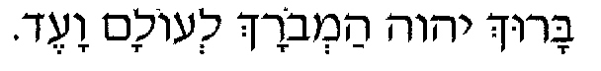
Barukh attach Adonai, eloheinu melekh ha-olam, asher bahar banu mi-kol ha-amim, v’natan lanu et torato. Barukh atah adonai, noten ha-to-rah. | 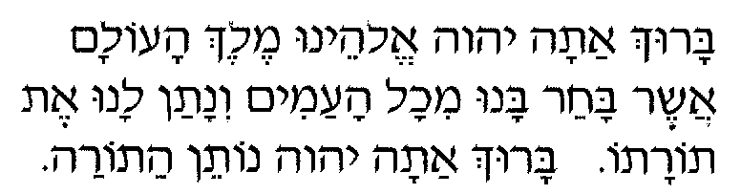
6. When the person is finished reading the aliah, he/she will point to the place where the aliyah ended. Please take the corner of your Tallit (Torah Tie), touch the place that was pointed to, and then kiss the Tallit (Torah Tie).
7. Recite the blessing after the Torah Reading:
Barukh attach Adonai, eloheinu melekh ha-olam, asher natan lanu torat emet, v’hayei olam nata b’tokhenu. Barukh atah adonai, noten ha-to-rah. | 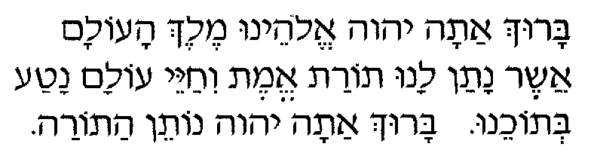
- For all individuals having an aliyah except the parents (if they are saying the optional parents blessing), after reciting the blessing, ,move to stand between the torah reader and the Gabbai standing on the Torah Reader’s left side and stand there for the next aliyah. After the next aliyah is finished, you may return to your seat in the pews.

INSTRUCTIONS FOR TYING THE TORAH (Glilah):
1. NOTE: A person’s Hebrew Name, for the purpose of an aliyah, consists of the person’s Hebrew Name plus the Hebrew name of the person’s father. It may also include the Hebrew Name of the person’s mother but it does not have to do so.
Your Hebrew name: ________________________________________________
Father’s Heb. Name:__________________ Mother’s Heb. name: _________________
2. When asked to do so by the usher, please walk up to the stairs on the right side of the bimah and take one of the seats that are at a 90 degree angle from where the Rabbi sits.
3. The Gabbai will ask you and the person who is lifting the Torah to stand next to him/her and will call both of you for your honors using your Hebrew names.
4. The person who is Hagbah will lift the Torah, hold the scroll so that the congregation can see the portion that was read, and then will sit in a chair.
5. Once the Hagbah sits in the chair, help the hagbah roll the Torah so that the parchment is tight and there is no slack between the two sides of the Torah.
6. Take the Torah tie and fasten it tightly around the Torah. The part where it is closed should face the person who is holding the Torah.
7. Take the Torah cover and put it over the Torah, with the front part of the Torah cover facing the person who is holding the torah.
8. The Gabbai will then take the Torah and put it on a Torah Stand. You can now return to your seat in the pews.
INSTRUCTIONS FOR PARENTAL BLESSING:
1. The Parental Blessing (optional) is said after the Bar/Bat Mitzvah is called for his/her maftir Aliyah. Before the Bar/Bat Mitzvah says the blessings, the Rabbi will ask you to recite the following in Hebrew and in English:
For a Boy:
TRANSLITERATION | HEBREW
Say this first:
Baruch Sheh-Peh-Ta_Ra-Nee May Onshow shel zeh.
Then say this in English:
Praised are you who releases me from the religious obligations of my son, and who has granted him the wisdom and maturity to accept his responsibilities as a young adult among the people of Israel.
For a Girl:
TRANSLITERATION | HEBREW
Say this first:
Baruch Sheh-Peh-Ta_Ra-Nee May Onshow shel zot.
Then say this in English:
Praised are you who releases me from the religious obligations of my daughter, and who has granted him the wisdom and maturity to accept his responsibilities as a young adult among the people of Israel.
INSTRUCTIONS FOR SHEHECHEYANU (Parents, Siblings, Grandparents):
- The Shehecheyanu Blessing is generally said after Aleinu. The Rabbi will ask the parents, siblings and grandparents to rise to say the blessing.

TRANSLITERATION | HEBREW
Say this first:
Baruch Ata Adonai, Elohaynu Melech Ha-Olam, Shehecheyanu, vekeyemanu, vehigeyanu la’zeman hazeh.
Then say this in English:
Praised are you, Lord Our God, Ruler of the Universe, who has kept us alive, sustained us, and brought us together to celebrate this Simcha, this moment of joy in the life of our family.

