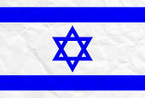

# Trip will be 12 nights, and will begin at the end of June or very early July, 2014

## **Itinerary will include**

## **3 days at Krakow Jewish**

## **cultural festival**

## **2 days in warsaw**

## **visit to Auschwitz-birkenau**

## **(option to stay in Krakow)**

## **3 nights in jerusalem**

## **3 nights in Haifa**

## **focus of trip in israel- learning about & visiting innovative companies to witness growth of israel as “the Start up Nation”**

## **plus sites of historical**

## **relevance.**

## **for itinerary, contact**

## **ellen.nesson@gmail.com**

✹

# Announcing upcoming trip in Summer, 2014

A Celebration of Jewish Renewal in Poland

and

Scientific Innovation in Israel

**dates & prices TBA shortly**

✹