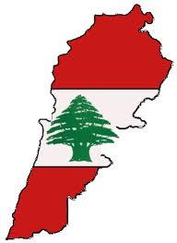
In the Footsteps of My Childhood: Last Summer in Lebanon
Lebanese Dinner and program
with Bert and Rachel Rosenheck

Friday AUGUST 16th 6 PM

Shabbat Service 8 pm ( please note service time)

Our synagogue member, Bert Rosenheck, was born and raised in Lebanon until the 1950's civil war forced his family to flee to Paris. He eventually made his way to the United States, but never lost his love of the country and its way of life. Last summer, after more than 50 years, Bert and Rachel returned to Lebanon, to find his roots.
Join us Friday night for a delicious milchig ( milk) Lebanese dinner while Bert and Rachel will share their extraordinary experiences as Jews in Lebanon today, with the people who befriended them, and the sites and sounds of old and new.

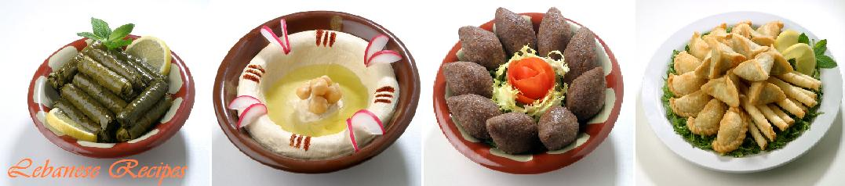Cost for the dinner $15 per adult
children $8
under 5 free
Bring your own bottle of Kosher Wine

RSVP TO OFFICE@mjcby or call the office 973 538 9292 by AUGUST 9TH

