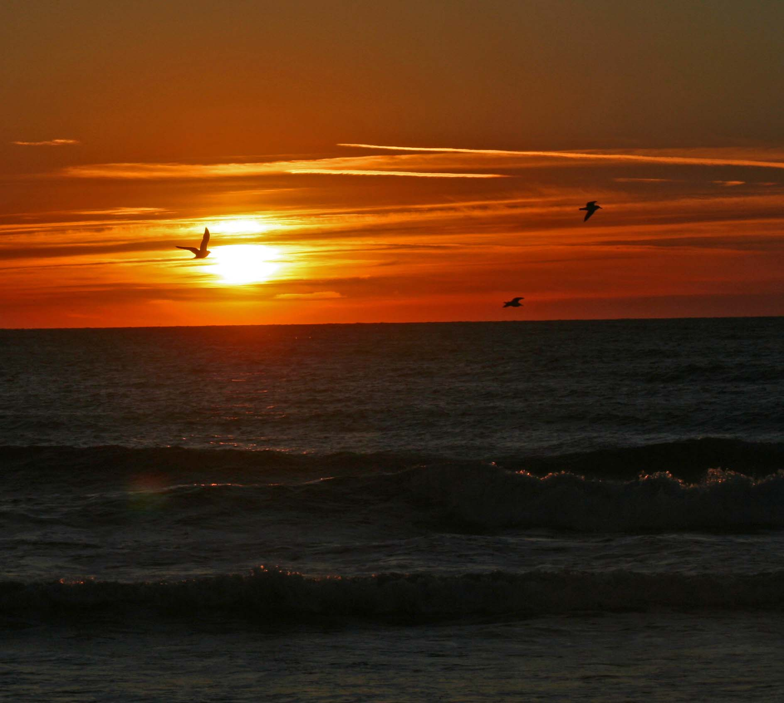
Join us for Barechu & You
Sunset Shabbat & Dinner
Friday, August 9th

Freedom Park , Millbrook Road ,Randolph

BBQ & Dinner 6 to 7PM

7PM Musical Kabbalat Shabbat Followed by Ma’ariv

Adults $10 Kids Under 12 Free *
Open to the Community

rsvp to Mia office@mjcby.org 973-538-9292

Traditional Synagogue Service 8:15PM

