MORRISTOWN JEWISH CENTER BEIT YISRAEL

PRESENTS
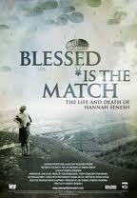
BLESSED IS THE MATCH
The story of Hannah Senesh.
I
In commemoration of YOM HASHOAH, Holocaust Memorial Day
Sunday April 7, 2013
10 am at MJCBY (mjcby.org)

All members of the community are invited

Blessed Is the Match is an award winning movie. It is the first documentary feature about Hannah Senesh, the World War II-era poet and diarist who became a paratrooper and resistance fighter. With unprecedented access to the Senesh family archive, this powerful film chronicles the only military rescue mission for Jews during the Holocaust through the writings and photographs of Hannah and her mother Catherine.

Director Roberta Grossman is an award-winning filmmaker with a passion for history and social justice.

You can learn more about the film and view the trailer at our website: www.blessedisthematch.com.

