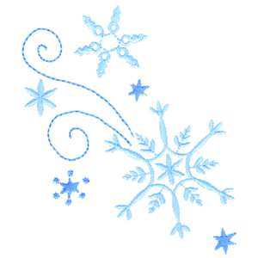

Presents: Snowball Extravaganza

Date: Sunday, January 13, 2013

Time: 12:00 – 2:00 pm

Cost: FREE – FREE – FREE

Lunch: Hot homemade waffles with sliced fruit: blueberries, strawberries and peaches. Sprinkle with powdered sugar snow. Maple syrup and whipped cream if you like.

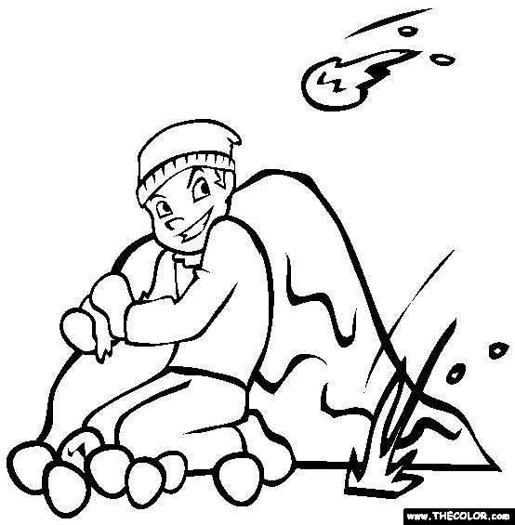Dessert: Ice Cream Snowball Floats

Vanilla Ice Cream & Root beer

Activities: Indoor Snowball Fight

 Giant Snowball Races

Build a Snowman Station



**Don’t Miss Out**: RSVP to [jrsababah@gmail.com](mailto:jrsababah@gmail.com)

**Please let us know by Jan. 9th**

Or Call - Gigi Schwartz @ 973-599-0168