Me & My Shadow formerly Mommy & Me
Shalom Yeladim-The Judie Gerstein Early Learning Center
at the morristown Jewish Center Beit Yisrael
Circle Time, Snack & Schmooze
Children ages 1month - 24 months
Continues throughout the summer when Shalom Yeladim is in session.
Monday Mornings at 9:15-10:15AM
June 17, 24 July 1, 8, 15 August 5, 12
Me & My Shadow (Mommy & Me) is designed with specific games and activities to develop important skills in children. Each class is a fun, interactive and a multi-sensory experience for the caregiver and child. Classes are for babies and children from birth to 18 months old.
It is a great opportunity for Parents and their children to make new and lasting friendships while enjoying an age appropriate program.
This classes meet Monday mornings when Shalom Yeladim is in session.
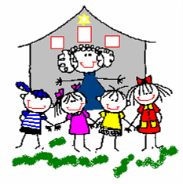
Open to the Community
For more information call 973-538-9292
177 Speedwell Avenue Morristown NJ 07960
mjcby.org

