Amazing, Creative and Unique
after lunch activities at Shalom Yeladim

Sign up today. Enrichments last until 2:30pm

Mondays AWESOME ART

A fun filled workshop which will ignite the children’s imagination and creativity through media arts.
Tuesdays SUPERMARKET ABC’S  Shop in our “Kid Dish” supermarket where the children will find all the items you’d expect to find at our local grocer and in your own homes. Through imaginative play, the children will learn about phonics and more! They will “check out” with their carts filled with groceries and their minds filled with knowledge. | 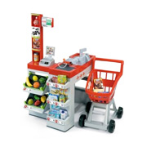

Wednesdays X-PERIMENTING

WITH EXPERIMENTS

Looking for gooey, volcanic and slimy fun? Science comes alive as children explore the fascinating world around them and take part in fun experiments that will awe them and put big smiles on their faces!
Thursdays STOP AND SHOP  Back to our supermarket where the children will learn many math concepts like counting, one to one correspondence, even & odd numbers. Using a cash register they will learn about money too! | 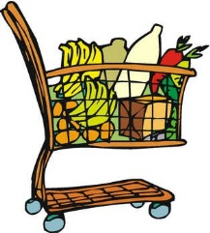

Fridays YOUTHFUL YOGA

Returns to guide your children through basic relaxation techniques and simple yoga poses. Mats and soothing music will help make this a very “zen” hour.

