**Child’s Name ____________________________________**



**Parents’ Names ____________________________________**

**Address_________________________________________**

**City/State/Zip___________________________________**

**Phone_________________________________________**

**email_________________________________________**

**Child’s DOB __________________________________**

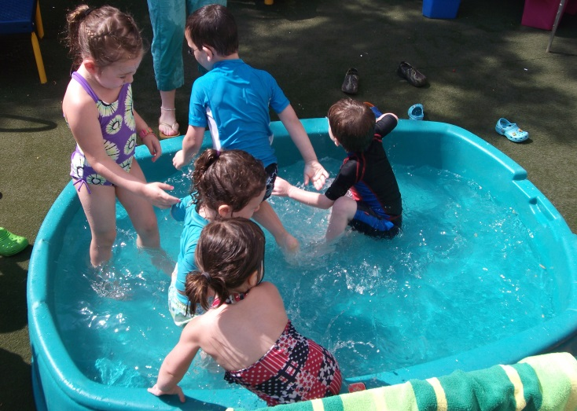Shalom Yeladim-  
The Judie Gerstein   
Early Learning Center

***Shalom Yeladim-The Judie Gerstein   
Early Learning Center   
A Program of the***

***Morristown Jewish Center Beit Yisrael***

***177 Speedwell Avenue  
Morristown, NJ 07960  
973-538-8284  
mjcby.org***

C:\Users\mia\AppData\Local\Microsoft\Windows\Temporary Internet Files\Content.IE5\KTYFJYOE\MC900138777[1].wmf

**Fun Program 2014**

**7 Weeks of Fun and Play!**

Beginning June 30, 2014

9:30am to 1:00pm

or

9:30am to 3:00pm

**Early Drop Off Available**

Designed for children age 18 mos – 5yrs, our program takes children back to summers past… fun, play and splashing! Organized theme weeks give way to hands-on exploration. Whether we are paleontologists searching for dino footsteps or medieval prince and princesses, every day brings a world of excitement. Daily splashing in the kiddie pool, sand play and playground fun help our children experience summer as it was meant to be. The program led by Morah Sharon, aims to socialize the children through a warm, nurturing, creative and playful day. Join us for a summer of fun!

Hours: Two Options- 9:30am -1:00pm OR 9:30am- 3:00pm

Registration Fee $50 per child or $80 per family.  
 **Register by Fri. 3/7/14 & Registration Fee Will be Waived**

Deposit $100

5 Days, 1:00pm Dismissal

5 Days, 3pm Dismissal M-F

See Registration for 2, 3 & 4 day a week options

10% Discount for Second Child

Deposit and Registration Fees must accompany forms

Undersubscribed days will need to be eliminated

Hot lunch included in cost of program

Complete the form, including back page and return in your child’s backpack or to the office. Questions call Susan Gold 973-538-8284 [sy@mjcby.org](mailto:sy@mjcby.org)

Place an X in the box that corresponds to the number of days and dismissal times for your children for each day he/she will be attending the Summer Fun Program. Additionally, if attending less than 5 days, please indicate days. Please total the last columns.

|  |  |  |  |  |  |  |  |  |  |
| --- | --- | --- | --- | --- | --- | --- | --- | --- | --- |
| **Number of Days & Dismissal Time** | **Cost** | **Wk 1** | **Wk 2** | **Wk 3** | **Wk 4** | **Wk 5** | **Wk  6** | **Wk 7** | **Tuition Total** |
| **5 days/1pm** | **$285** |  |  |  |  |  |  |  |  |
| **4 days/1pm** | **$225** |  |  |  |  |  |  |  |  |
| **3 days/1pm** | **$170** |  |  |  |  |  |  |  |  |
| **2days/1pm** | **$120** |  |  |  |  |  |  |  |  |
| **5days/3pm** | **$305** |  |  |  |  |  |  |  |  |
| **4days/3pm** | **$265** |  |  |  |  |  |  |  |  |
| **3 days/3pm** | **$205** |  |  |  |  |  |  |  |  |
| **2 days/3pm** | **$135** |  |  |  |  |  |  |  |  |
| **8am drop off** | **$50/Wk** |  |  |  |  |  |  |  |  |
| **2 & 3 & 4 day options, must indicate days** | **M**  **T**  **W TH**  **F** | **M T W TH F** | **M T W TH F** | **M T W TH F** | **M T W TH F** | **M T W TH F** | **M T W TH F** | **M T W TH F** |  |
| **TOTAL** |  |  |  |  |  |  |  |  | **Total** |