

### Shalom Yeladim- The Judie Gerstein Early Learning Center, a program of the Morristown Jewish Center Beit Yisrael 177 Speedwell Avenue Morristown, NJ 07960

### [www.mjcby.org](http://www.mjcby.org) Visit us on Facebook www.facebook.com/shalomyeladimnurseryschool

Kindergarten Program

Half Day AM Program to complement the

Public school system.

Open to families of all faiths and beliefs

* Early Drop off 7:30
* Kindergarten 9 am – 12 pm
* Transportation available to   
  all Randolph Schools
* Full Day Option Available
* Licensed by the State of New Jersey

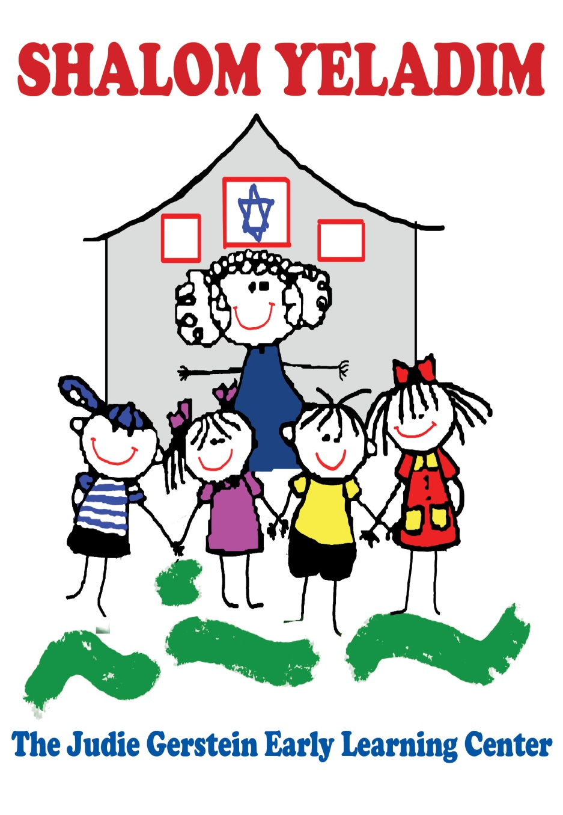

Give your child a “jump start”   
to their elementary years…

Our academic program will:

Establish a Strong Reading Foundation

•Ability to hear and identify individual sounds in spoken words

•Show reading comprehension and eagerness towards reading

•Use a sight vocabulary to build sentences and apply writing strategies to convey meaning

•Apply phonetic strategies for spelling

•Learn through experience charts and labeling

Enhance Mathematical Thinking

•Learn about shapes and patterns, geometry and measurement and number sense and numeration

•Solve simple addition and subtraction problems

•Recognize one to one correspondence

•Count forward to 100 by ones, fives and tens and distinguish between halves, wholes and quarters

•Know the meaning of less than, greater than and equal to

•Be able to tell time

•Understand how money and numbers correlate

Support the Development of Good Citizenship

•Learn the purpose of laws and rules and understand what it means to be a good citizen

•Acquire a historic understanding of American holidays

•Recognize and appreciate the similarities and differences in people and cultures around the world

Foster An Inquisitive View of Science

•Observe the world around them

•Explore the topography of our world

•Learn about the life cycle of nature and animals

Shalom Yeladim - The Judie Gerstein Early Learning Center is pleased to offer a half-day and full- day Kindergarten enrichment as an alternative or complement to the public school system. Early literacy, science, math, art, social studies and Judaic studies are all part of the excellent introduction to academics.

The Kindergarten year is a remarkable year of growth and development for your children. After a strong preschool foundation, each child is poised to explore their world in new and exciting ways. Our teachers and staff feel privileged to guide your child on this important journey. Our Kindergarten program draws from our belief that all children can flourish academically when their social and emotional development is actively encouraged.

### The year will focus on supporting the public school curriculum by building strong reading foundations, good analytical skills, community awareness and everyday math skills. The learning environment is enhanced by electives including music, art and computers.

### Preschool 18 months to 5 yrs Extended Day 7:30am to 6pm

### Register today

### Call for details and to arrange a tour of our school. 973-538-8284 mjcby.org

### 