# Building Bridges to the FutureBRIDGES MINI-CAMP EXPERIENCE Shalom Yeladim-The Judie Gerstein Early Learning Center at the morristown Jewish Center Beit Yisrael

Let us bridge your two weeks between school and the beginning of the camping season!

Mini Camp Experience   
Monday, June 17th to Friday, June 21st   
June 24th to June 28th  
Hours: 7:30am to 6pm OR 9:30am to 2:30pm  
Ages: Children 18mos to 5yrs

Fill out the information sheet and return in your child’s backpack to school or synagogue office.   
-----------------------------------------------------------------------------------------------  
Child’s Name _____________________________ Birth Date ________

Address:___________________________________________________  
Parent(s) Names: ____________________________________________  
Phone: Email:

*Circle your choices below:*

Week 2 June 24th - June 28th  
9:30am - 2:30pm Daily Rate $55/per day ($275/week)

7:30am - 6pm $65/per day or $325/week  
OR choose your own hours @ $15/hr (list below)

Week 1 June 17th -21st  
9:30am - 2:30pm Daily Rate $55/per day ($275/week)

7:30am - 6pm $65/per day or $325/week  
OR choose your own hours @ $15/hr (list below)

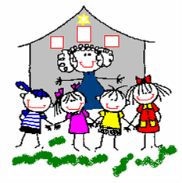mjcby.org